(Approx. 401 words)

Photography: Make the most of your flash
By David Stonier-Gibson, Editor, Melbourne PCUG, Australia
June 2018 issue, >PC_Update
www.melbpc.org.au
davidsg@melbpc.org.au

Most cameras these days have a built-in flash. And we all know a flash is there just for those occasions when there’s not enough light to take a good photo, right? Well, maybe not. There’s much more to getting the most out of a flash than just allowing the camera to automatically flash when it’s dark. Read on …
Whether you are using a phone camera with its inbuilt LED flash, a pocket point and shoot camera with an inbuilt flash, or a fancy DSLR with a pop-up flash or even externally mounted “serious” flash gun, there is something here for you.

Flash in bright sunlight

I sometimes tell people I use my flash when there’s too much light. It’s all good and well taking snaps of the children on the beach on a nice sunny day, but the harsh sun will cause harsh shadows. Using a flash can often reduce the shadows and highlight the subject.



Fill flash for a bright background
The camera will tend to expose for the bulk of the picture, which is the bright background. By activating the flash I have both the subject and the background looking good.

How often have you seen a social snapshot or selfie where the subject was up against a window or other bright background, and consequently dark and lacking in detail. Use the flash to illuminate the subject. If your equipment allows the strength of the flash to be controlled, dialing it down a bit may improve the result.

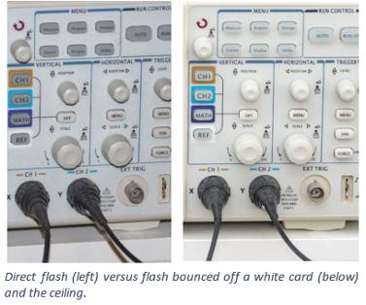
Avoiding harsh shadows from your flash

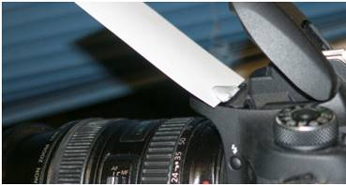

Using a flash in low light social situations (aka parties) will produce harsh shadows on and behind the subject. If you have an external flash gun you can point it up at 45 degrees and bounce it off the ceiling. If you have a fixed pop-up flash, you can improvise a reflector from a white card to get a similar effect.

Reduce redeye
A camera mounted flash, especially in a phone or pocket camera, will produce that dreaded redeye effect. Not pretty! Bouncing the flash off the ceiling will get rid of it. If that’s not possible, most photo editing software, even in phones, has a redeye reduction tool, and some cameras can reduce redeye by a brief flash before taking the actual shot.



